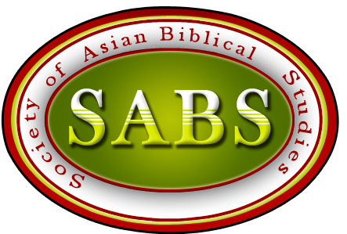

Society of Asian Biblical Studies (SABS)

Bi-Annual Membership Form, 2024-2025

Name: First:____________________________ Last:_____________________________

(Please circle: New Member or Renewal)

Address: ________________________________________________________________

________________________________________________________________________

________________________________________________________________________

Country ___________________________ Email: _______________________________

Home phone _______________________ Office phone __________________________

(Please circle: I do / do not want my email address or phone number published.)

Membership Categories and Dues Rates

Student member: US$20.00 for two years

Full member (from Asia/Africa/Latin America/the Pacific except Australia, New Zealand, Hong Kong, Japan, Korea, Singapore, and Taiwan) US$30.00 for two years

Full member: (from Australia, New Zealand, Hong Kong, Japan, Korea, Singapore, and Taiwan ) US$50.00 for two years

Full member (from outside of Asia/Africa/Latin America/the Pacific) US$50.00 for two years

Lifetime member: (with one-time payment) US$500.00

Dues amount: ________________________

General Research Interests (Please circle)

Hebrew Bible/Old Testament | Textual Criticism
Pentateuch | Translation Theories/Practices
Deuteronomistic History | Historical Criticism
Prophets | Literary/Narrative/Rhetorical Criticism
Wisdom literature | Social Scientific Criticism
Apocalyptic Literature | Contextual/Vernacular Hermeneutics
New Testament | Liberation Hermeneutics
Gospels | Feminist Criticism
Acts | Marxist Criticism
Pauline/Deutero Pauline Epistles | Postcolonial Criticism
General Epistles | Queer Criticism
Revelation | Ecological Criticism
Intertestamental literature | Disability Studies and the Bible
Receptions of the Bible | Biblical Theologies
Pedagogical issues within biblical studies | Others:

Actual fees can be paid on site during our upcoming SABS Conference.

